**MAVEN (Build Tool)**

1. Build tools similar tools in market - Apache ANT , Gradle , Babmbo, Travis CI, Cicrle CI, Team City, Build Master, Codeship, MS Build...etc
2. Maven is a Build tool and Project management tool also.
3. Maven used to **compile** and create **executable** file.(.jar,.war,.ear)
4. Maven will maintain project folder structure.
5. Maven will maintain pom.xml and ANT will maintain build.xml file for building the code.
6. Maven required jdk software, should be installed first in the machine **jdk8**.

**Internet connection is required.**

**Jdk8 installation:-**

[**https://www.oracle.com/in/java/technologies/javase/javase-jdk8-downloads.html**](https://www.oracle.com/in/java/technologies/javase/javase-jdk8-downloads.html)

**OR**

**Jdk9 installation:-**

<https://www.oracle.com/java/technologies/javase/javase9-archive-downloads.html>

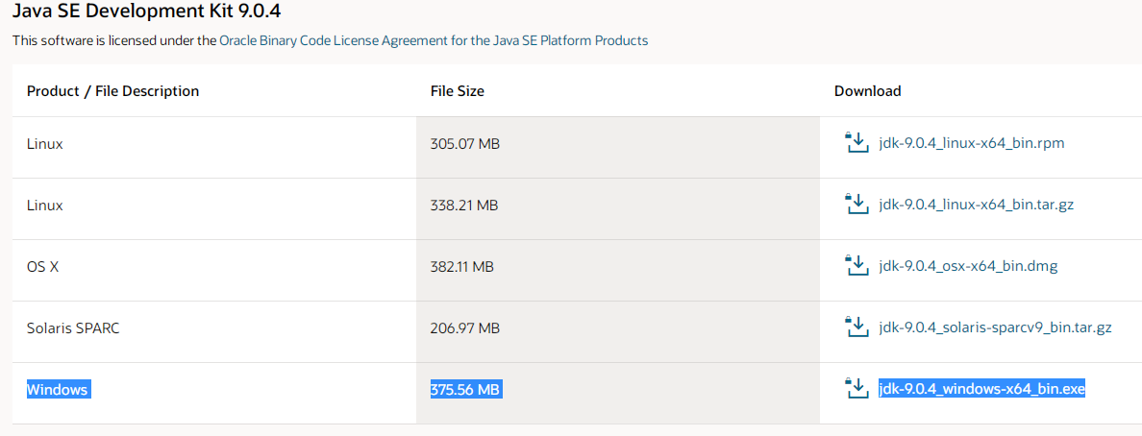

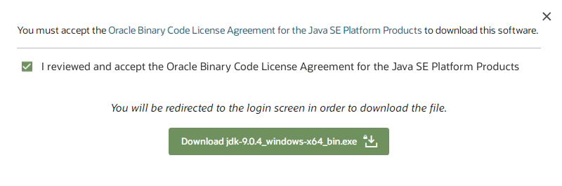





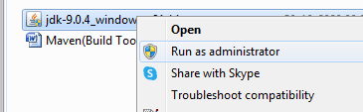

Click Yes

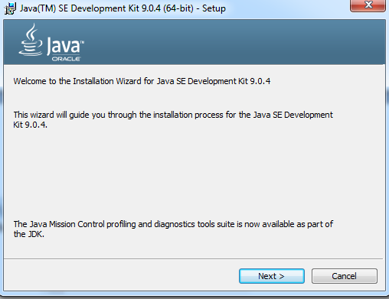

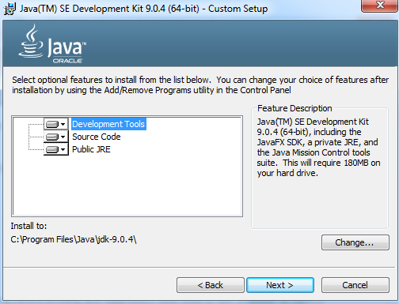

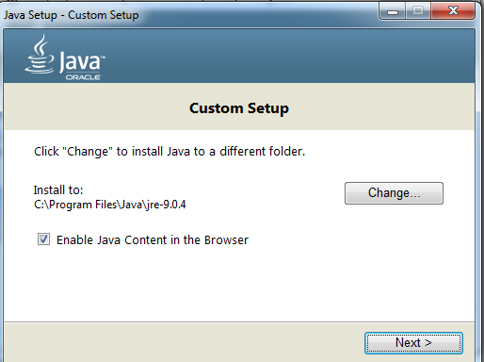

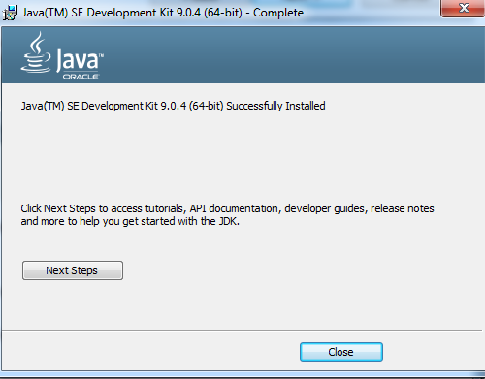

**Set Java class path:-**

Goto: - C:\Program Files\Java\jdk-9.0.4\bin

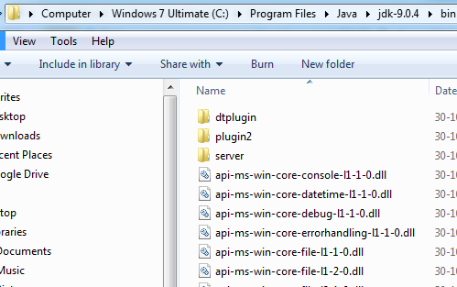

Right click on my computer

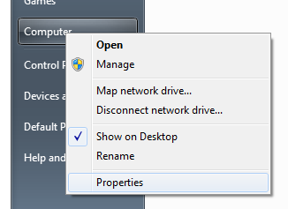

JAVA_HOME =C:\Program Files\Java\jdk-9.0.4\

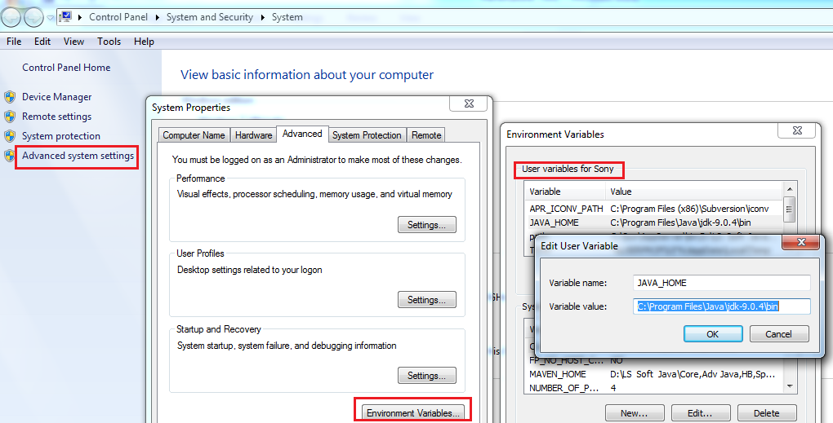

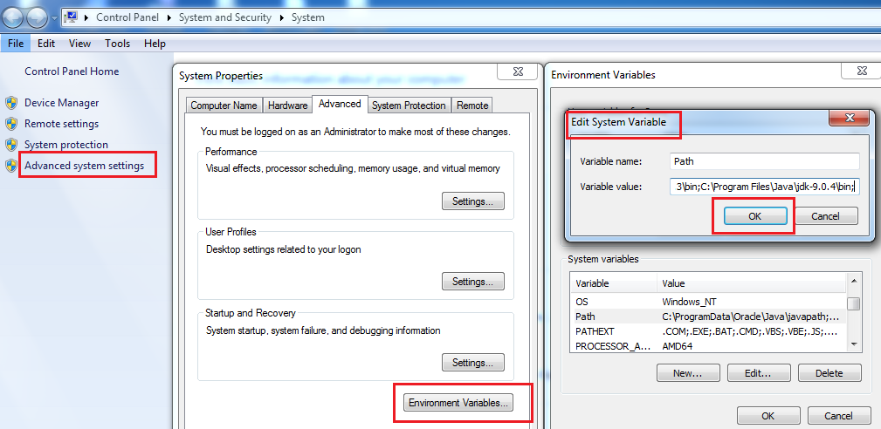

**Open cmd:-**

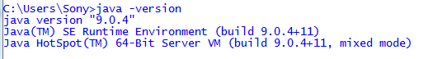

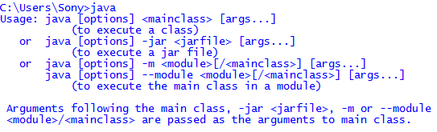

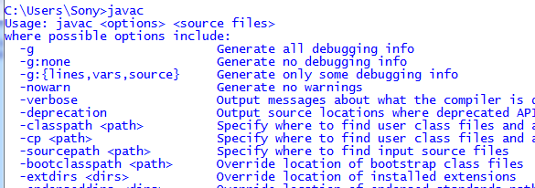

**Maven Setup:-**

[**http://maven.apache.org/download.cgi**](http://maven.apache.org/download.cgi)

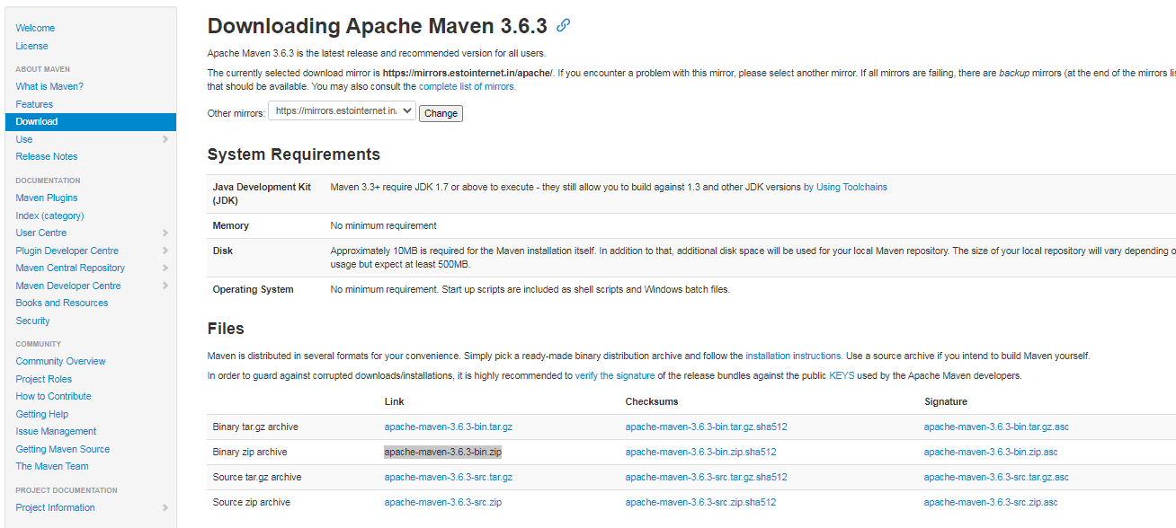

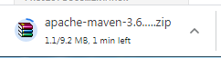 **Extract Zip file**

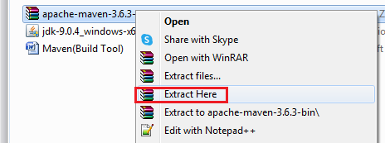

**Set Up Envrmt Path for Maven:-**

D:\DevOps & AWS Training Data\DevOps_Tutorials\3.Maven\apache-maven-3.6.3

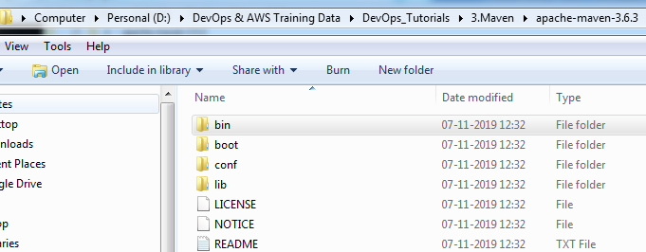

Right click on my computer



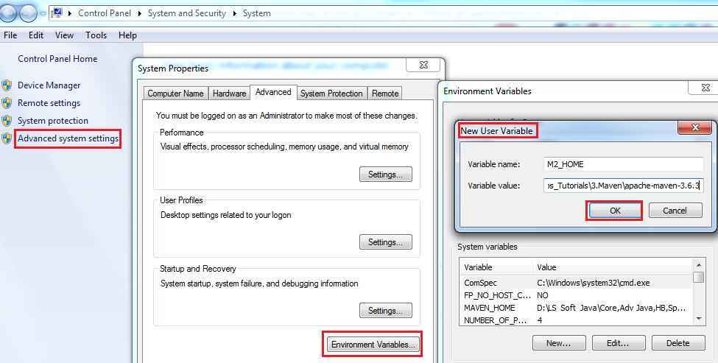

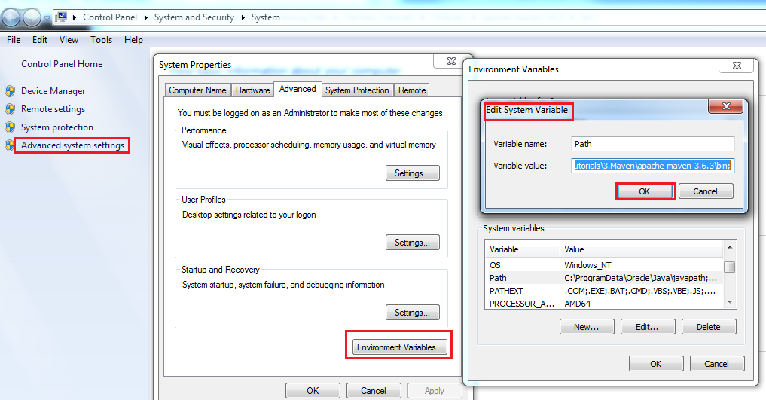

**Open CMND:- mvn**

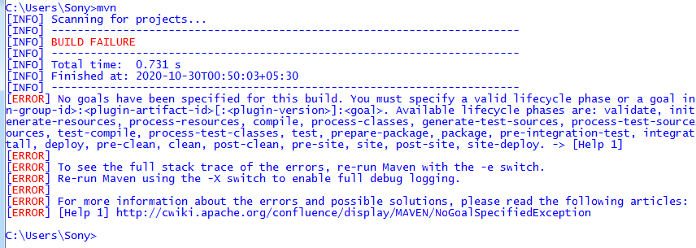

Note: If not shown above build failure/success, your not stepped properly jdk/maven.

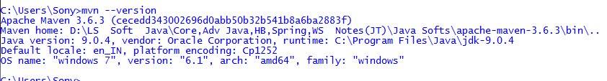

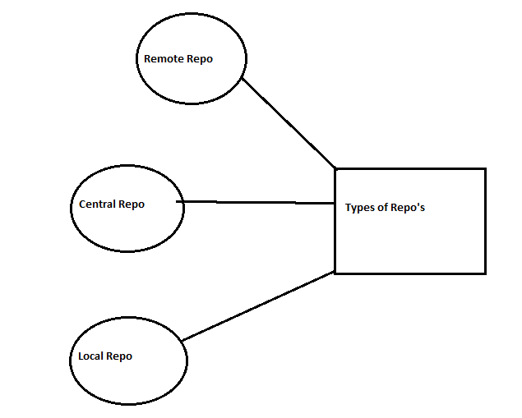

Local repository:- C:\Users\Sony\.m2

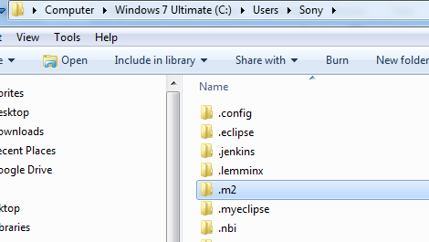

Sample maven pom.xml: <https://www.jetbrains.com/help/idea/convert-a-regular-project-into-a-maven-project.html#develop_with_maven>

Create one mvn folder.

Open cmnd :- goto inside folder

D:\DevOps & AWS Training Data\DevOps_Tutorials\3.Maven\mvn>**mvn archetype:generate** -> This cmnd used to generate folder structure for any project.

Enter

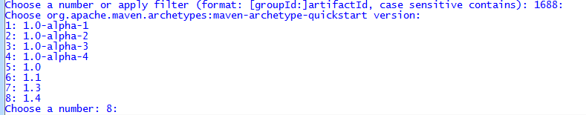

Again Enter

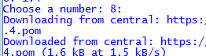

Connecting central repository and downloading maven dependency.

Provide all group id, artefact id, version....

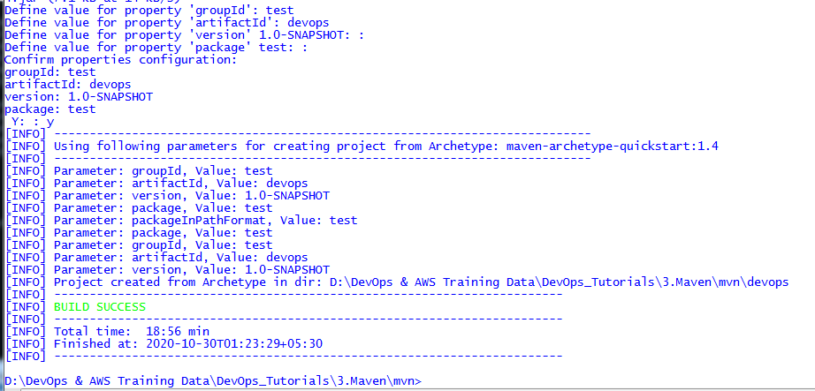

2nd time :- mvn archetype:generate -> This cmnd used to generate folder structure.

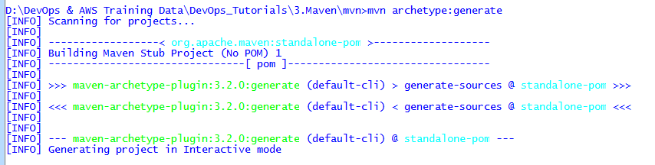

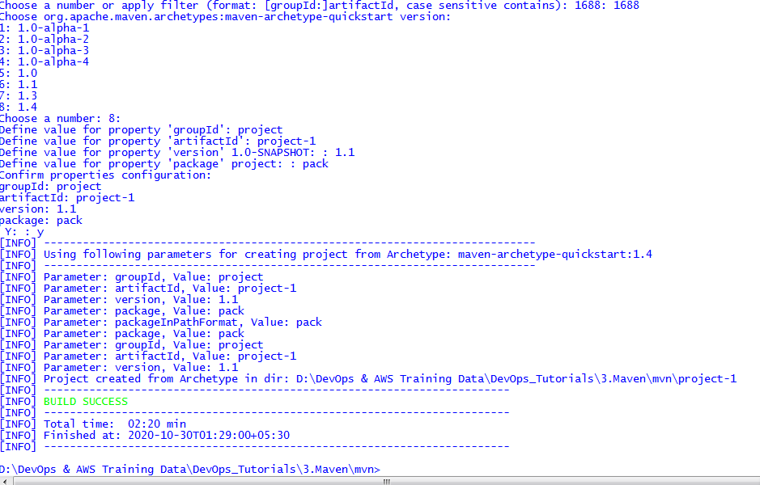

Here 2 folders are created

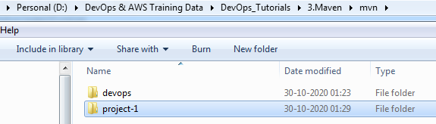

mvn archetype:generate > maven.out -> used to create out put of above build result.

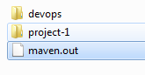

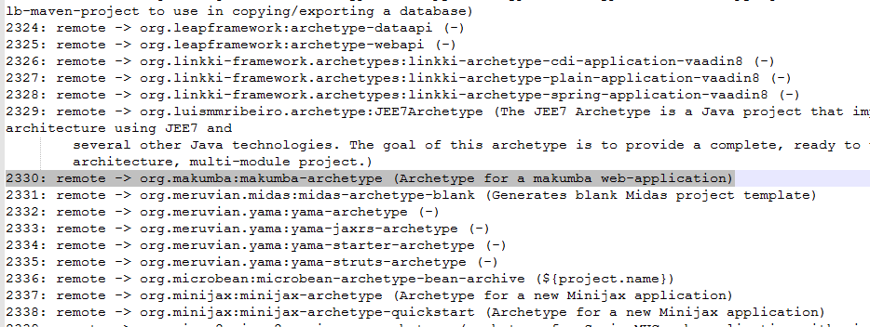

For spring mvc appln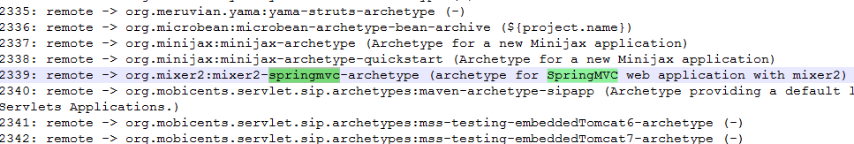

mvn archetype:generate (one more for web appln)

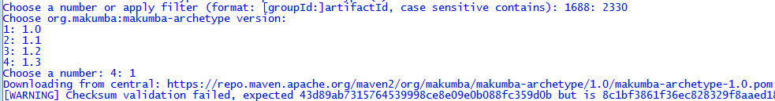

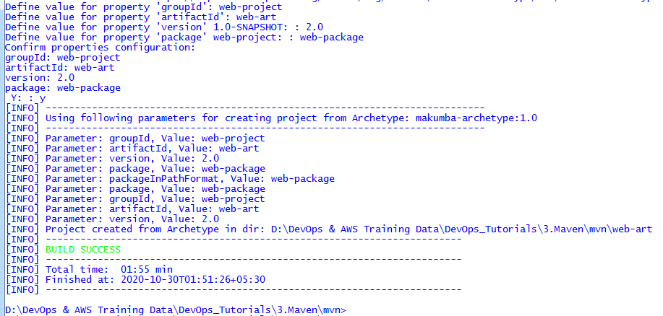

Web Project created.

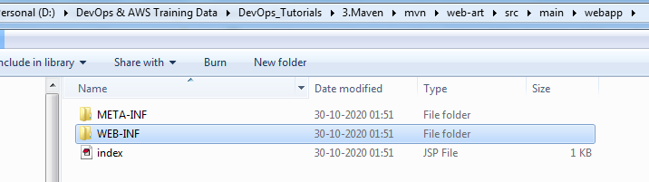

**How to create executable file:-**

**Goto our web project**

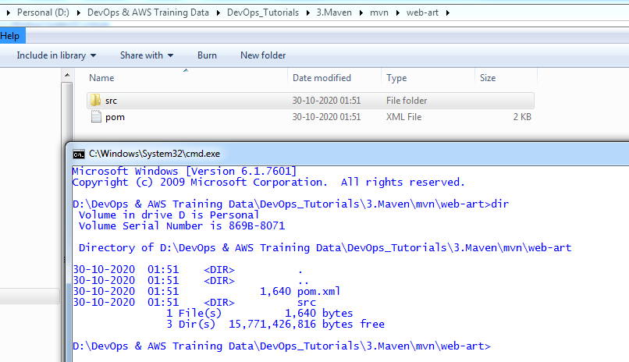

Run maven goals:- mvn test -> will download all test cases related dependencies.

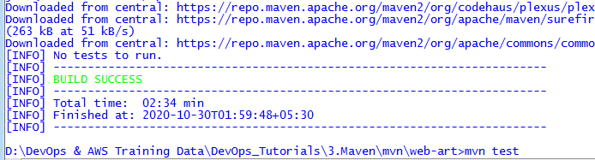

Target folder is created

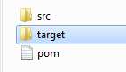

mvn clean :- for clean the executable files(target folder will remove).

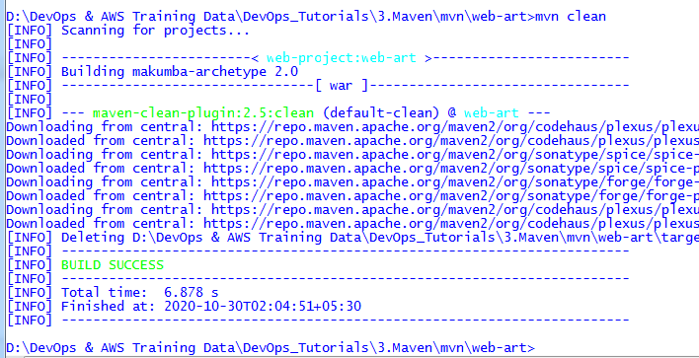

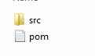

mvn compile :- for compile the code

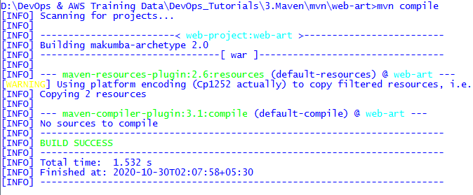

**mvn clean install** :- compile and package(jar/war).

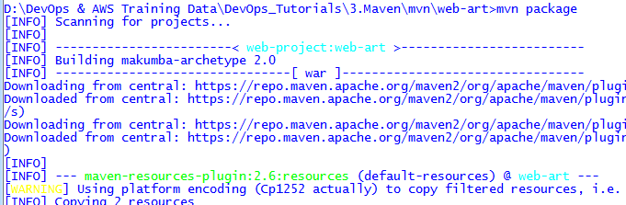

Jar/War file is created

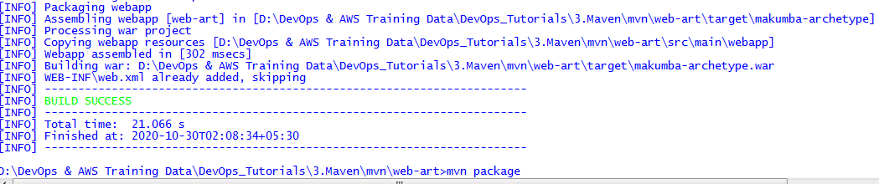

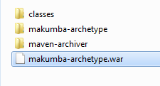

**Maven Setup in Linux (CentOS):-**

**Jdk11 installation:-**

[**https://www.oracle.com/in/java/technologies/javase-jdk11-downloads.html**](https://www.oracle.com/in/java/technologies/javase-jdk11-downloads.html)

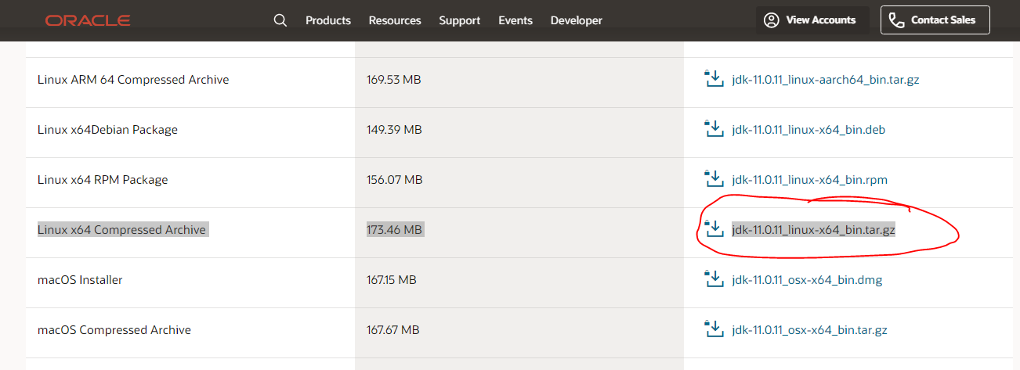

**OR**

**Jdk8 installation:-**

[**https://www.oracle.com/in/java/technologies/javase/javase-jdk8-downloads.html**](https://www.oracle.com/in/java/technologies/javase/javase-jdk8-downloads.html)

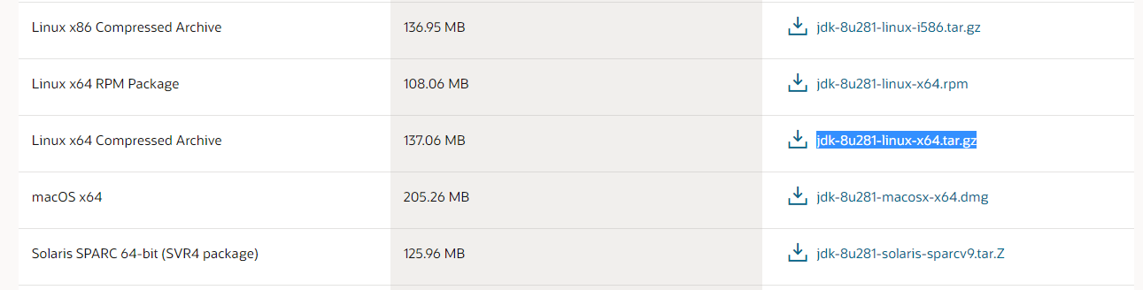

**Move this file from windows to Linux machine:- use Winscp tool**

[**https://winscp.net/eng/download.php**](https://winscp.net/eng/download.php)

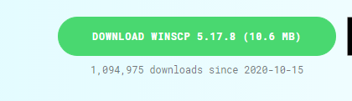



** double click , SCP means secure copy**

**Click new site**

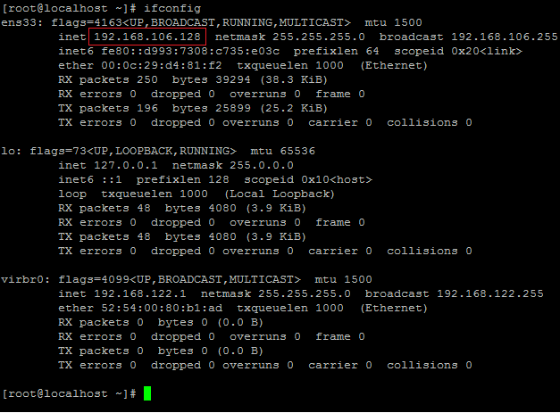

**Provide hostname, un, pwd.**

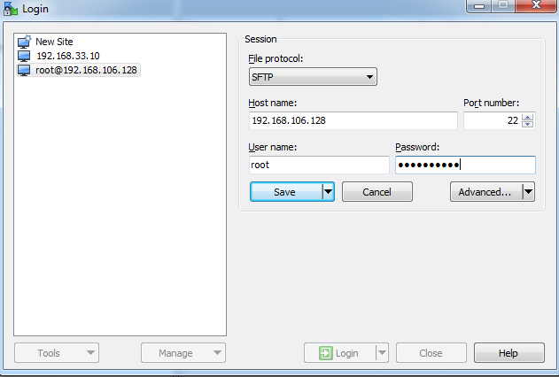

**Click yes**

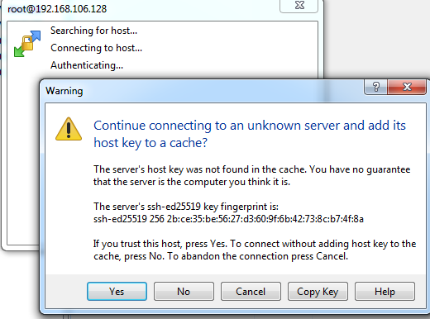

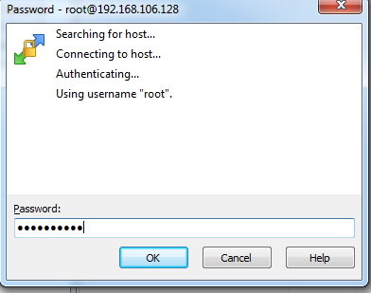

**Drag the file from source to destination folder from windows to linux. (same way copy files from linux to windows)**

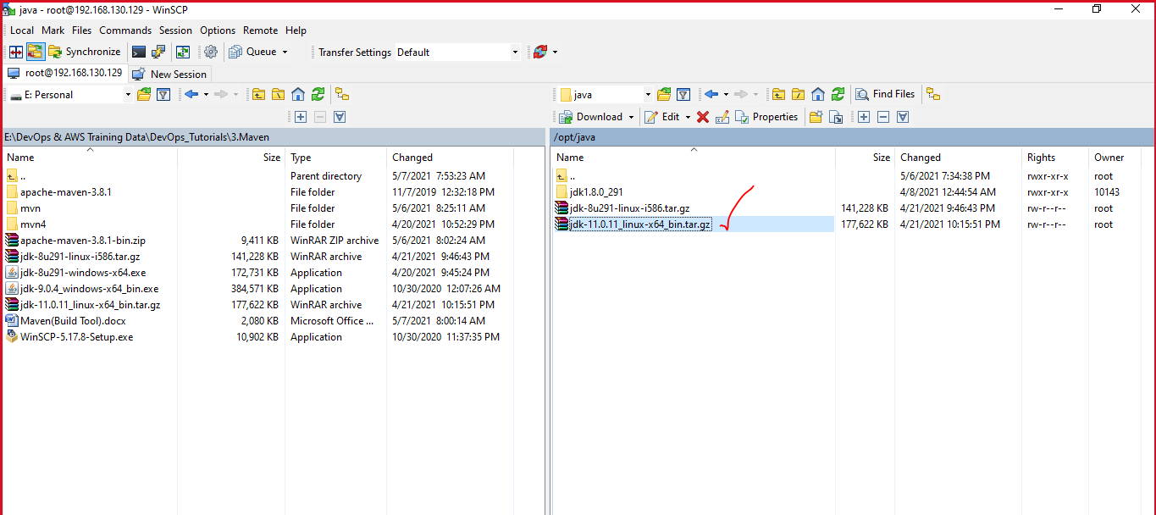

**File moved to linux**

**[root@localhost java]# tar -xvf jdk-9.0.4_linux-x64_bin.tar.gz -> Extract the tar file.**

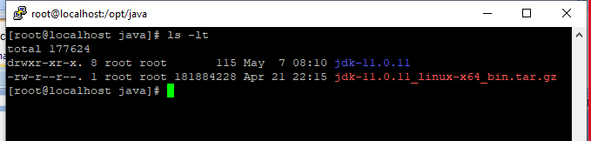

**set the java environments variable path:-**

**[root@localhost jdk-11.0.11]# vi /etc/profile.d/java.sh**

**Java.sh:-**

**export JAVA_HOME=/opt/java8/jdk1.8.0_291**

**export PATH=${JAVA_HOME}/bin:${PATH}**

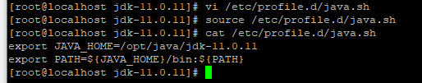

**Source cmd-> execution done.**

**Check java version**

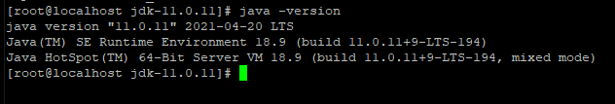

**set the maven environments variables:-**

**[root@localhost jdk-11.0.11]# yum install wget -> to install wget package**

**[root@localhost jdk-11.0.11]# rpm –qa wget ->verify wget is installed or not.** 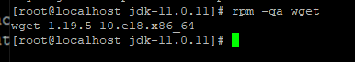

[root@localhost opt]# mkdir maven -> created one directory under opt dir.



Goto maven dir

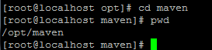

<http://maven.apache.org/download.cgi> 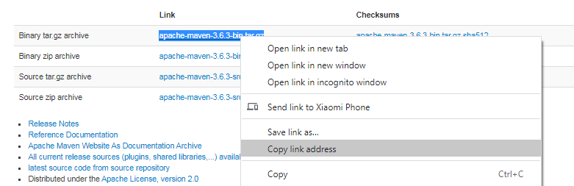

[root@localhost maven]# **wget** https://mirrors.estointernet.in/apache/maven/maven-3/3.6.3/binaries/apache-maven-3.6.3-bin.tar.gz ->copied url paste here

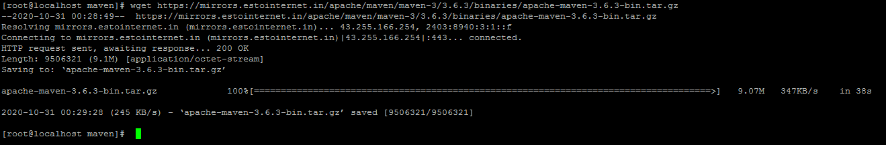

[root@localhost maven]# tar -xvf apache-maven-3.6.3-bin.tar.gz ->Extract the tar file

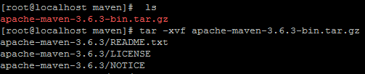

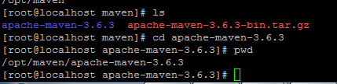

**[root@localhost jdk-9.0.4]# vi /etc/profile.d/maven.sh**

**maven.sh:-**

**export M2_HOME=/opt/maven/apache-maven-3.6.3**

**export PATH=${M2_HOME}/bin:${PATH}**

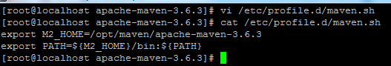

**[root@localhost jdk-9.0.4]# source /etc/profile.d/maven.sh**



Verify maven version:-

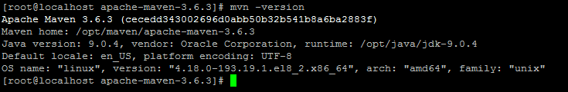

Verify maven build:-

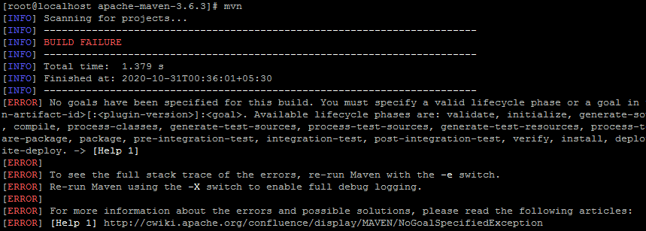

Verify local repository created or not:- .m2 dir

[root@localhost /]# cd /root/.m2/ -> local repository created (.m2 dir)

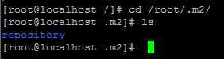

[root@localhost opt]# mkdir mvn -> create one mvn dir under opt dir.

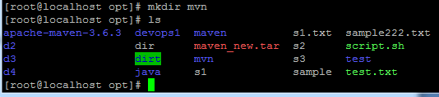

<https://mvnrepository.com/> -if you want add any dependency get from here.

Create mvn project:-

[root@localhost opt]# mvn archetype:generate -> create mvn project structure

Enter project number and provide all project details.

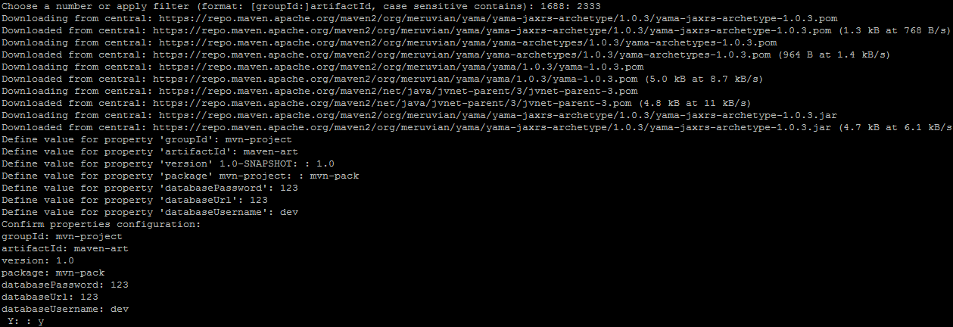

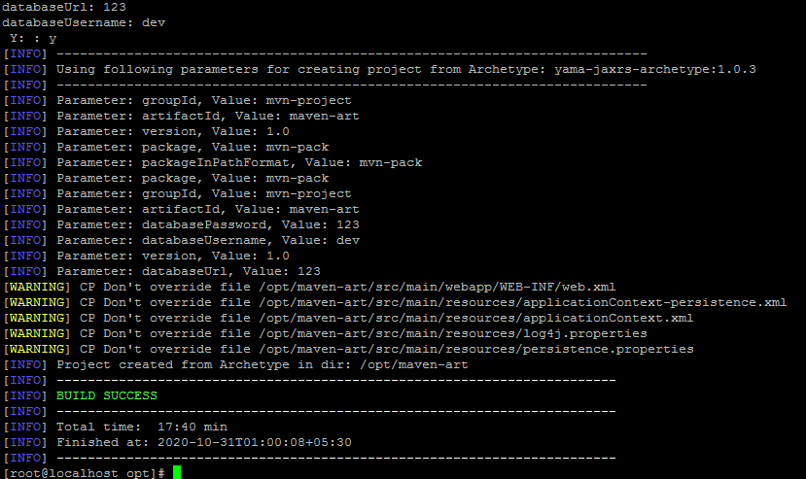

Created maven-art project.

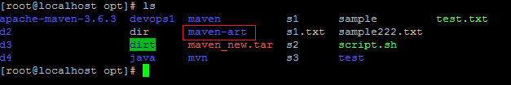



**Maven Goals:- mvn clean install (only use in real time, clean ->clean the target, install->install target folder)**

* *validate:* check if all information necessary for the build is available
* *compile:* compile the source code
* *test:* run unit tests
* *package:* package compiled source code into the distributable format (jar, war, …)
* *installl:(compile+package)* install the package to a local repository(jar, war, …)

**[root@localhost maven-art]# mvn install**

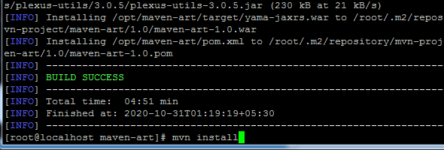

**Target dir created**



**[root@localhost maven-art]# mvn clean-> clean the target dir**

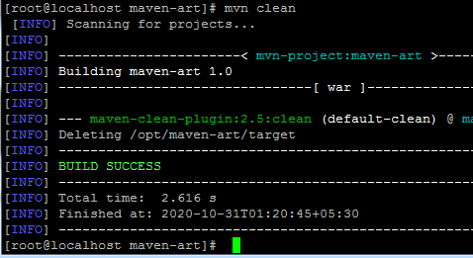



**Like execute all goals... clean , test ,validate , compile, package or install.**

**Refer:** [**https://maven.apache.org/guides/introduction/introduction-to-the-lifecycle.html**](https://maven.apache.org/guides/introduction/introduction-to-the-lifecycle.html) **=======================================END MEVEN=========================================**